NEW PATIENT HEALTH QUESTIONNAIRE

YOUR DETAILS

Full Name …………………………………………………………………………… Date of Birth ___/___/___

Address ………………………………………………………………………………………………………………………..

…………………………………………………………………………………………………………………………………..

*The NHS and your GP surgery can use these details to call, text or email you about health care services. All phone numbers must be registered in the UK*

Email Address..………………………………………………………………………………………………………………..

Tel No …………………………………………………. Mobile No ………………………………………………………...

ABOUT YOU

Next of Kin – Who should we contact in an emergency?

Name………………………………………………….................. Relationship……………………………………………..

Contact telephone number/s……………………………………………………………………………………………….....

Please tell us your Weight in kg……………………………… and Height in cm…………………………………….....

Do you have any allergies Yes [ ] No [ ]

If yes please detail here.......................................................................…...................................................................

Do you smoke? Please select from list below

 | Yes | No
Never smoked tobacco
Ex-smoker
Light cigarette smoker (1-9 a day)
Moderate cigarette smoker (10-19 a day)
Heavy cigarette smoker ( 20-39 a day)
Electronic cigarette user
Ex user of electronic cigarette
Prefer not to disclose

Medication – Are you on regular prescription medication?

We use the electronic prescribing system; please ensure you nominate a local pharmacy of your choice to receive your prescription electronically once issued by a clinician.

Your nominated pharmacy is: …………………………………………………………………………………………….

Carers

Are you a Carer? Do you provide help and support to a Relative, Friend or Neighbour who cannot manage without this help due to their age, disability, or health needs? Yes [ ] No [ ]

Are you someone who is cared for? Yes [ ] No [ ] Carer Name……………………………………………………..

Carer contact telephone number/s……..……………………………………………………………………………………..

Do you have any learning disabilities we need to be aware of Yes [ ] No [ ]…………………………………………
…………………………………………………………………………………………………………………………………….

We’re improving how we communicate with patients. Please tell us if you need information in a different format or need communication support during your booked appointments.

Do you require [ ] First Language Interpreter [ ] Sign Language interpreter [ ]N/A

FAMILY HISTORY

Please tick and indicate family connection
Condition | Yes | No | Family Member  (Mother, Father, Sister, Brother, Aunt, Uncle or Grandparent)
Alzheimer’s disease or dementia
Asthma
Cancer
Diabetes
Epilepsy
Heart disease
High blood pressure (Hypertension)
Stroke
Thyroid disease
Other

What is your Ethnicity?

Please tick one of the following

[ ] Asian or Asian British – Bangladeshi
[ ] Asian or Asian British – Indian
[ ] Asian or Asian British – Pakistani
[ ] Asian or Asian British – Other Asian background
[ ] Black or Black British – African
[ ] Black or Black British – Caribbean
[ ] Black or Black British – Other Black background
[ ] Chinese
[ ] Mixed – White and Asian
[ ] Mixed – White and Black African
[ ] Mixed – White and Black Caribbean
[ ] Mixed – Other missed background
[ ] White – British
[ ] White – Irish
[ ] White – Other White background
[ ] Prefer not to disclose my ethnicity
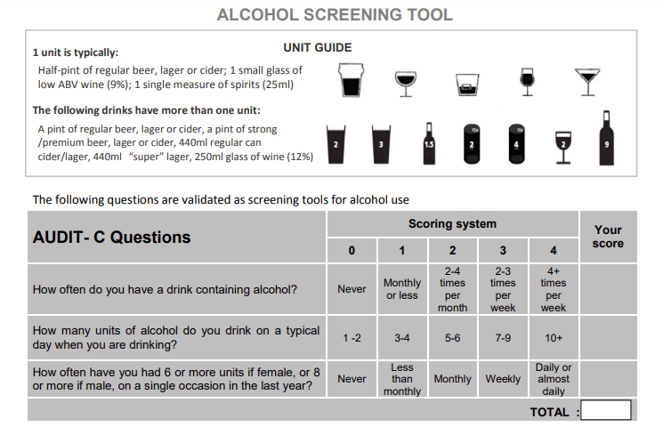

Privacy Consent

This form collects personal and medical information about you. We use this information to complete your registration with the practice and allow the practice team to contact you. Please read our Privacy Policy to discover how we protect and manage your submitted data.

[ ]I consent to the practice collecting and storing my data from this form.

Information for new patients: about your Summary Care Record

Dear patient,

If you are registered with a GP practice in England, you will already have a Summary Care Record (SCR), unless you have previously chosen not to have one. It will contain key information about the medicines you are taking, allergies you suffer from and any adverse reactions to medicines you have had in the past.

Information about your healthcare may not be routinely shared across different healthcare organisations and systems. You may need to be treated by health and care professionals who do not know your medical history. Essential details about your healthcare can be difficult to remember, particularly when you are unwell or have complex care needs.

Having a Summary Care Record can help by providing healthcare staff treating you with vital information from your health record. This will help the staff involved in your care make better and safer decisions about how best to treat you.

You have a choice

You have the choice of what information you would like to share and with whom. Authorised healthcare staff can only view your SCR with your permission. The information shared will solely be used for the benefit of your care.

Your options are outlined below; please indicate your choice on the form overleaf.

- Express consent for medication, allergies and adverse reactions only. You wish to share information about medication, allergies for adverse reactions only.

- Express consent for medication, allergies, adverse reactions and additional information. You wish to share information about medication, allergies for adverse reactions and further medical information that includes: your illnesses and health problems, operations and vaccinations you have had in the past, how you would like to be treated (such as where you would prefer to receive care), what support you might need and who should be contacted for more information about you.

- Express dissent for Summary Care Record (opt out). Select this option, if you DO NOT want any information shared with other healthcare professionals involved in your care.

If you chose not to complete this consent form, a core Summary Care Record (SCR) will be created for you, which will contain only medications, allergies and adverse reactions.

Once you have completed the consent form, please return it to your GP practice.

You are free to change your decision at any time by informing your GP practice.

Copyright © 2017Health and Social Care Information Centre. The Health and Social Care Information Centre is a non-departmental body created by statute, also known as NHS Digital.

Summary Care Record patient consent form

Having read the above information regarding your choices, please choose one of the options below and return the completed form to your GP practice:

Yes – I would like a Summary Care Record
- Express consent for medication, allergies and adverse reactions only.

or

- Express consent for medication, allergies, adverse reactions and additional information.

No – I would not like a Summary Care Record
- Express dissent for Summary Care Record (opt out).

Name of patient: ………………………………………………..….........................

Date of birth: …………………………… Patient’s postcode: …………………

Surgery name: …………………………… Surgery location (Town): ………..................

NHS number (if known): …………………………..………………...................................

Signature: ……………………………. Date: ………………………………

If you are filling out this form on behalf of another person, please ensure that you fill out their details above; you sign the form above and provide your details below:

Name: ………….........................................................................................................

Please circle one:
Parent | Legal Guardian | Lasting power of attorney
 |  | for health and welfare

For more information, please visit https://www.digital.nhs.uk/summary-care-records/patients, call NHS Digital on 0300 303 5678 or speak to your GP Practice.

For GP practice use only

To update the patient’s consent status, use the SCR consent preference dialogue box and select the relevant option or add the appropriate read code from the options below.

Summary Care Record consent preference | Read 2 | CTV3
The patient wants a core Summary Care Record (express consent for | 9Ndm. | XaXbY
medication, allergies and adverse reactions only)
The patient wants a Summary Care Record with core and additional | 9Ndn. | XaXbZ
information (express consent for medication, allergies, adverse reactions and
additional information)
The patient does not want to have a Summary Care Record (express dissent | 9Ndo. | XaXj6
for Summary Care Record – opt out)

Copyright © 2017Health and Social Care Information Centre. The Health and Social Care Information Centre is a non-departmental body created by statute, also known as NHS Digital.

